课程:英语口语（三）复习资料
Topic: Economy
Hello, welcome to the Advanced Spoken English Test. We wish you both good luck today. Now let’s start by introducing yourselves.
Student A, would you please go first? (时间30秒)
Thank you. Student B, now it’s your turn. (时间30秒)
Thank you. OK, now that we know each other, let’s move on.
Part 1 Read Aloud
In this part, you will read aloud a short passage. You will have 1 minute to go over the passage and one minute to read it aloud. Here is the passage.
Passage 1
Sleep is important for both physical and mental health. According to a study, losing over two hours of sleep will make people feel angry. The study shows that sleep loss brings people some bad emotions such as worry and sadness. They can make people's positive emotions like happiness less. What's more, the study shows that losing sleep can make people become angry directly
In the study one group had their normal sleeping hours, while the other group slept less each night for two nights. The first group had almost seven hours of sleep a night, while the other group got about four and a half hours.

Passage 2
The difference was to show what people usually experience in their daily lives. Then the researchers asked both groups to finish different work while listening to the terrible noise in order to create an uncomfortable environment and cause feelings of anger.
The study leader said, “Usually, anger was higher for those who don't get enough sleep.” “We controlled how terrible the noise was during the study, and like what we expected, people would become angrier when the noise made people less comfortable. When people didn't get enough sleep, they became angrier, whether there was noise or not," he added.

(考生准备1分钟)
Now, Student A, read Passage 1 please.(考生A朗读，时间1分钟)
Now, Student B, read Passage 2 please.(考生B朗读，时间1分钟)
Ok. Now we are going to answer the questions. You have 30 seconds to respond.
Question 1: What would happen if people lose over two hours of sleep?（考生A回答）
Question 2: What did the researchers ask both groups to do?（考生B回答）
(考生准备30秒)
Now, Student A, answer Question 1 please. (30秒)
Now, Student B, answer Question 2 please. (30秒)
Part 2 Individual Presentation
In this part, you will talk about the pictures displayed below. You have 1 minute to prepare and one minute to talk about it. Now here are the pictures.
Picture 1 Picture 2
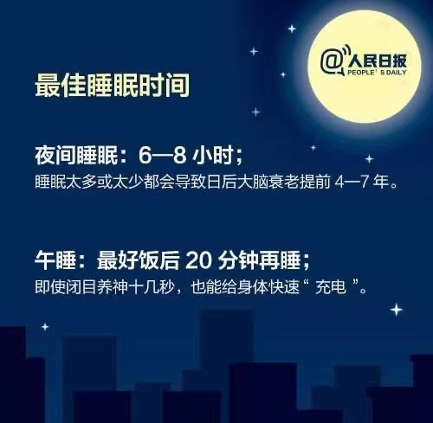

(考生准备1分钟)
Now, Student A, talk about Picture 1 please. （时间1分钟）
Now, Student B, talk about Picture 2 please. (时间1分钟)
Part 3 Pair Work
In this part, you will talk with your partner about the question “How to sleep well?” Your talk may include:
--- many people stay up late
--- many people don’t sleep well
--- my advice to sleep well
You will have one and a half minutes to prepare and three minutes to talk. Remember, this is a pair activity and you need to interact with each other. Your performance will be judged according to your contribution to the pair work. Now please start to prepare.
(考生准备时间1分钟30秒)
Now please start to speak. (3分钟)
Thank you. That is the end of the test.
评分标准
评分基于以下三个标准（准确性和范围、话语长短和连贯性、灵活性和适切性、流利度），每个单项满分5分。其中：
1）准确性指语音语调以及语法和词汇的准确程度，范围指词汇和语法结构的复杂度和丰富度；
2）话语长短指学生对整个考试中的交际所做的贡献、讲话的多少，连贯性指学生能够进行较长时间的、语言连贯的发言：
3）灵活性指学生应付不同场景和话题的能力率，适切性指学生根据不同场合选用确切语言的能力；
4）流利度指学生在朗读短文时流利顺畅、意群停顿恰当、内容完整。
 | 准确性和范围 | 话语长短和连贯性 | 灵活性和适切性 | 流利度
5分 | - 语法和词汇基本正确  - 词汇丰富、语法结构较为复杂  - 发音较好，但允许有一些不影响理解的母语口音 | - 能进行较长时间的发言，语言连贯  - 组织思想和搜寻词语时偶尔出现停顿，但不影响交际 | - 能自如地应对不同场景和话题  - 能积极地参与讨论  - 语言使用总体上能与语境、功能和目的相适应 | - 意群停顿恰当，语音语调正确  - 朗读流利，基本没有重复和更正  - 内容完整
4分 | - 语法和词汇有一些错误，但未严重影响交际  - 词汇较丰富  - 发音尚可 | - 能进行较连贯的发言，但多数发言较简短  - 组织思想和搜寻词语时频繁出现停顿，有时会影响交际 | - 能较自如地应对不同场景和话题  - 能较积极地参与讨论  - 语言使用基本上能与语境、功能和目的相适应 | - 有少量意群停顿错误，语音语调有一些错误，但未严重影响听者理解  - 朗读较为流利，有少量重复和更正  - 内容基本完整
3分 | - 语法和词汇有错误，且有时会影响交际  - 词汇不丰富，语法结构较简单  - 发音有缺陷，有时会影响交际 | - 发言简短  - 组织思想和搜寻词语时频繁出现较长时间且影响交际的停顿，但能基本完成交际任务 | - 不能积极地参与讨论  - 有时不能适应话题或内容的转换 | - 有较多意群停顿错误，语音语调也有较多错误，有时影响听者理解  - 朗读不够流利，有较多停顿、重复、更正  - 内容不够完整
2分 | - 语法和词汇有相当多的错误，交际时常中断  - 词汇和语法结构缺乏，严重影响交际  - 发音较差 | - 发言简短且毫无连贯性，基本不能进行交际 | - 不能参与讨论 | - 意群停顿完全混乱，语音语调大量错误，严重影响听者理解  - 朗读有大量听者、重复、更正  - 内容支离破碎
1分 | 不描述 | 不描述 | 不描述 | 不描述

