英语口语复习资料

Topic: Education
Hello, welcome to the Advanced Spoken English Test. We wish you both good luck today. Now let’s start by introducing yourselves.
Student A, would you please go first? (时间30秒)
Thank you. Student B, now it’s your turn. (时间30秒)
Thank you. OK, now that we know each other, let’s move on.

Part 1 Read Aloud
In this part, you will read aloud a short passage. You will have 1 minute to go over the passage and one minute to read it aloud. Here is the passage.
Passage 1
Schools across the world are trying to come up with solutions to keep students active. At a school in America, students have adopted a new program that requires riding fixed bikes while reading. The teacher came up with the idea while he was exercising and reading at the gym. Believing it would be a fun way to convince students to become more active, he placed one in the corner of his classroom and encouraged them to use it during independent reading classes. It was so popular that he decided to add more bikes and offer the program to the entire school.

Passage 2
Besides making reading more fun, the program also helps students exercise at a comfortable pace, without the pressure that comes with regular sports-related activities. It is also a perfect way to release energy, during days when the weather is not helpful to outdoor activities. Most importantly, however, the program's academic benefits surprised everyone. A year after the Read and Ride program was introduced, students actively involved in the program demonstrated an astonishing 83% reading proficiency. Those that had not taken advantage of the exercise bikes tested at a much lower, 41%.

(考生准备1分钟)
Now, Student A, read Passage 1 please.(考生A朗读，时间1分钟)
Now, Student B, read Passage 2 please.(考生B朗读，时间1分钟)

Ok. Now we are going to answer the questions. You have 30 seconds to respond.
Question 1: Why did the teacher place a bike in the classroom? （考生A回答）
Question 2: What happened one year after the Read and Ride program was introduced?（考生B回答）
(考生准备30秒)

Now, Student A, answer Question 1 please. (30秒)
Now, Student B, answer Question 2 please. (30秒)

Part 2 Individual Presentation
In this part, you will talk about the pictures displayed below. You have 1 minute to prepare and one minute to talk about it. Now here are the pictures.
Picture 1 Picture 2
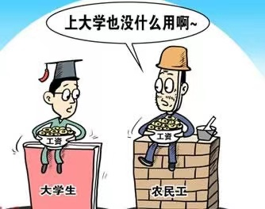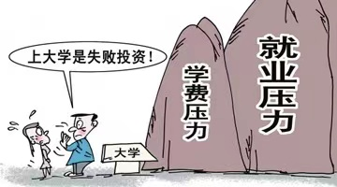
(考生准备1分钟)
Now, Student A, talk about Picture 1 please. （时间1分钟）
Now, Student B, talk about Picture 2 please. (时间1分钟)

Part 3 Pair Work
In this part, you will talk with your partner about the question: Is it necessary for us to go to colleges and universities? Your talk may include:
--- advantages of going to colleges
--- disadvantages of going to colleges
--- your own opinion

You will have one and a half minutes to prepare and three minutes to talk. Remember, this is a pair activity and you need to interact with each other. Your performance will be judged according to your contribution to the pair work. No please start to prepare.

(考生准备时间1分钟30秒)
Now please start to speak. (3分钟)

Thank you. That is the end of the test.

