英语口语（四）复习资料
Topic: Speeches
Hello, welcome to the Advanced Spoken English Test. We wish you both good luck today. Now let’s start by introducing yourselves.
Student A, would you please go first? (时间30秒)
Thank you. Student B, now it’s your turn. (时间30秒)
Thank you. OK, now that we know each other, let’s move on.

Part 1 Read Aloud
In this part, you will read aloud a short passage. You will have 1 minute to go over the passage and one minute to read it aloud. Here is the passage.
Passage 1
Public Speaking Tips.
    - Recall how you talk to your mother, girlfriend or boyfriend, chief financial officer or boss. It's usually different for each. So imagine that someone who loves and appreciates you is listening. Start out by imagining you're talking to them.
    - Successful public speakers project energy. They have to if they are to hold their audience from start to finish. They also know that if they stop concentrating on the words and the thread of their speech, so will the audience.
Believe what you say and deliver it with passion. The audience will sense if you're not sincere.

Passage 2
Polishing a presentation and avoiding errors.
You may find it useful to rehearse your presentation in front of a full-length mirror. It will not only help you perfect your delivery, it will also help you avoid a lot of common mistakes. For example, it will help ensure that you:
    - Don't drop your head when reading speech (many speakers type their speech only on the top half of pages).
    - Don't turn your back on audience.
    - Don't play with a pen or pointer.
    - Don't bend towards microphone.
    - Don't lean towards your notes.
    - Don't stare fixedly at notes.

(考生准备1分钟)
Now, Student A, read Passage 1 please.(考生A朗读，时间1分钟)
Now, Student B, read Passage 2 please.(考生B朗读，时间1分钟)

Ok. Now we are going to answer the questions. You have 30 seconds to respond.
Question 1: Why should successful speakers project energy?（考生A回答）
Question 2: How can a rehearsal help you?（考生B回答）
(考生准备30秒)

Now, Student A, answer Question 1 please. (30秒)
Now, Student B, answer Question 2 please. (30秒)

Part 2 Individual Presentation
In this part, you will talk about the pictures displayed below. You have 1 minute to prepare and one minute to talk about it. Now here are the pictures.
Picture 1 Picture 2
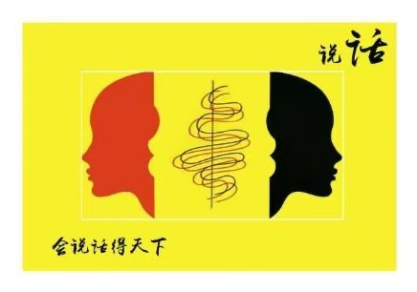
(考生准备1分钟)
Now, Student A, talk about Picture 1 please. （时间1分钟）
Now, Student B, talk about Picture 2 please. (时间1分钟)

Part 3 Pair Work
In this part, you will talk with your partner about giving a public speech. Suppose you are giving a speech in the English class, you are worried and turn to your partner for help. Your talk may include:
--- why you are worried
--- what is a good speech
--- how to prepare for the speech

You will have one and a half minutes to prepare and three minutes to talk. Remember, this is a pair activity and you need to interact with each other. Your performance will be judged according to your contribution to the pair work. No please start to prepare.

(考生准备时间1分钟30秒)
Now please start to speak. (3分钟)

Thank you. That is the end of the test.

口语考试按照以下步骤进行：

任务 | 内容 | 考试过程
热身 | 自我介绍 | 学生作自我介绍。每位学生30秒。考试时间约2分钟。
Part 1 | 短文朗读和简答 | 学生准备一分钟后，朗读一篇100词左右的短文并回答一个与短文有关的问题。考试时间约为5分钟。
Part 2 | 个人陈述 | 学生准备一分钟后，根据所给提示作个人陈述（每人1分钟）；考试时间约3分钟。
Part 3 | 两人讨论 | 两位学生就制定话题讨论进行讨论（准备一分钟30秒，讨论3分钟）。考试时间约5分钟。

